1. **System model**

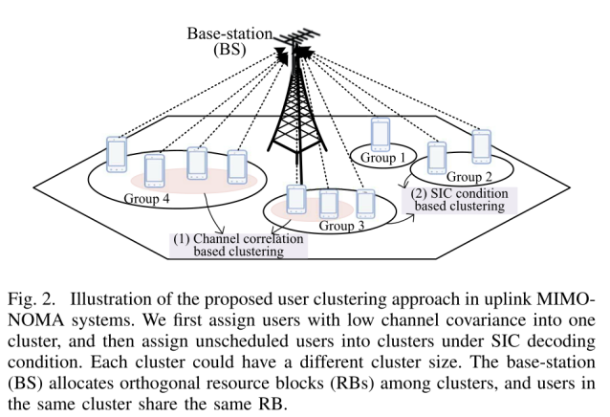

Our purpose is to group users into different clusters, and maximize different objective functions. For example, we can consider to maximize the sum rate , user fairness, and spectral efficiency, and so on.

When users in one cluster have low channel correlation, i.e., high channel rank, we can directly use multiple user detection to decode users’ signals.

When users in one cluster have high channel correlation, i.e., low channel rank, we need to use successive interference cancellation to decode users’ signals.

We want users in the same cluster to have high channel rank, and thus they would suffer less intra-interference.

1. **Some user clustering methods**

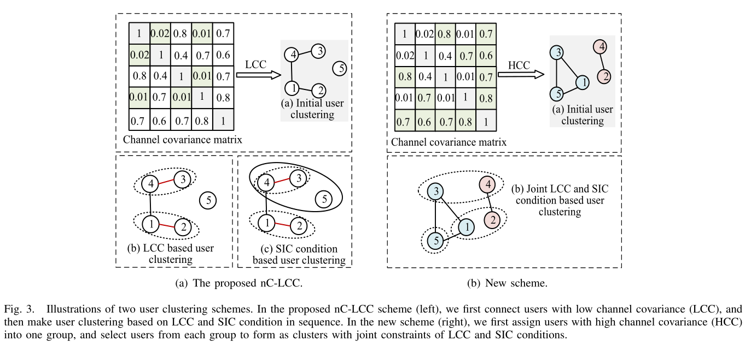

Supposing each user *i* has an *N*x1 channel vector , then we want to group these users into different clusters. We assume that each cluster has a maximum number of users.

Generally, there are two kinds of user clustering methods:

**Method 1:** In the first method (Fig. 3(a)), we first find users with low channel correlation, which means that they can form as high rank channel matrix, and then assign users with low channel correlation into one cluster.

**Method 2:** In the second method (Fig. 3(b)), we first find users with high channel correlation, which means that they have low rank channel matrix, and then assign them into different groups. Then, to reduce the channel correlation, we select users from different groups and form them as clusters.

If you want to calculate the channel covariance coefficient of two users, you can use **corrcoef**() function or **corr**() function with their channels in Matlab.